2025 NFDA Int’l Convention & Expo

Chicago, IL

**Policy: Affiliate & Exhibitor Functions Involving Convention Attendees**

Affiliates and exhibitors are not permitted to hold any function which involves convention attendees, including, but not limited to: meetings, seminars, food & beverage events, receptions, facility tours/open houses, etc. during the following days/times when official NFDA convention functions are occurring:

Sat, Oct. 25 8am – 5pm

Sun, Oct. 26 8am – 7:30pm

Mon, Oct. 27 8am – 5pm

Tue, Oct. 28 8am – 5pm

Wed, Oct. 29 8am – 1:30pm

There are no restrictions as to when affiliates and exhibitors may hold a function that does not include convention attendees, ie: business meeting involving organizational staff, sales staff, etc.

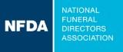

**2025 NFDA**

**International Convention & Expo**

**Chicago, IL**

**October 26-29**

**Affiliate/Exhibitor Meeting Space Request**

Dear Colleague,

The NFDA Meetings Department is ready to help you secure meeting space in Chicago, IL.

If you require meeting space at the McCormick Place Convention Center Monday, October 27th, 2025 – Wednesday, October 29th , 2025, review the document Policy: Affiliate & Exhibitor Functions Involving Convention Attendees for guidelines. Email any questions or complete and email the document Affiliate/Exhibitor Meeting Space Request Form to me at [kklemens@nfda.org](mailto:kklemens@nfda.org). Meeting space is assigned on a first come, first served basis, and is based upon NFDA approval.

Limited complimentary meeting space is available. After that the McCormick Place Convention Center may offer space with a rental cost. You are responsible for all charges related to your meeting.

Email confirmation will be sent to the contact noted on the Meeting Space Request Form within two weeks of receipt by NFDA. All approved requests will be forwarded to McCormick Place at which time they will contact you to begin planning your event and establish payment.

Thank you for your support and see you in Chicago.

Kristi Klemens

Director Convention, Meetings and Events

NFDA

13625 Bishop’s Drive

Brookfield, WI 53005

KKlemens@nfda.org

www.nfda.org

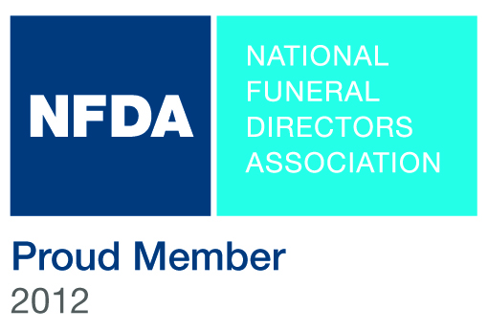

**2025 NFDA International Convention & Expo, Chicago, IL**

**Affiliate/Exhibitor Meeting Space Request Form**

*Meeting space is assigned on a first come, first served basis.*

|  |  |  |  |  |  |  |  |  |  |  |  |  |  |  |
| --- | --- | --- | --- | --- | --- | --- | --- | --- | --- | --- | --- | --- | --- | --- |
| Contact Name |  | | | | | | | | | Title |  | | | |
| Company Name |  | | | | | | | | | | | | | |
| Mailing Address |  | | | | | | | | | | | | | |
| Phone |  | | | | | | | | | Fax |  | | | |
| Email |  | | | | | | | | | | | | | |
| Event Name |  | | | | | | | | | | | | | |
| Event Day/Date | Monday, Oct 27th | | | Tuesday, Oct 28th | | | | Wednesday, Oct 29th | | | | Other | | |
| Event Start/  End Time |  | | |  | | | |  | | | |  | | |
| Type of Event | Business Mtg.  Reception | | | | | Other: | |  | | | | | | |
| Speaker/Topic | Name: |  | | | | | | Topic: |  | | | | | |
| On-site Contact | Name: |  | | | | | | | | Cell # |  | | | |
| Arrival Date: |  | | Arrival Time: | |  | | Departure Date: | |  | | | Departure Time: |  |
| Room Set Up:  *Check set-up types* | Conference:  boardroom10 | | Hollow Sq.  square | | U-Shape  ushape | | | Classroom  wkshop | | Theatre  theatre | | | Rounds  banquet | Reception  recep |
| Stage  Yes  No | | Stage Size | | Podium  Table Top  None  Standing | | | | | Other | | | | |
| Estimated #  of Attendees |  | | | Who are the attendees? | | |  | | | | | | | |
| Meeting  Requirements  *🗸All that apply* | Audio Visual Internet Food & Beverage | | | | | | | | Other | |  | | | |
| Special  Instructions |  | | | | | | | | | | | | | |

Email this form to the NFDA Meetings Department: Kristi Klemens, [kklemens@nfda.org](mailto:kklemens@nfda.org)

Meeting Related Charges:

All charges are the responsibility of the requesting company or organization including, but not limited to, room rental, room set changes, food and beverage, delivery, set-up, audio visual, internet, electric services, and other meeting related charges.

Please sign to acknowledge that you have read and understand the above statement.

|  |  |  |  |
| --- | --- | --- | --- |
| Signature |  | Date: |  |

For Administrative Use:

NFDA ❑ Approved ❑ Denied Date

Name Signature

Comments